MONGODB ASSIGNMENT

1. Retrieve all products in the "Electronics" category

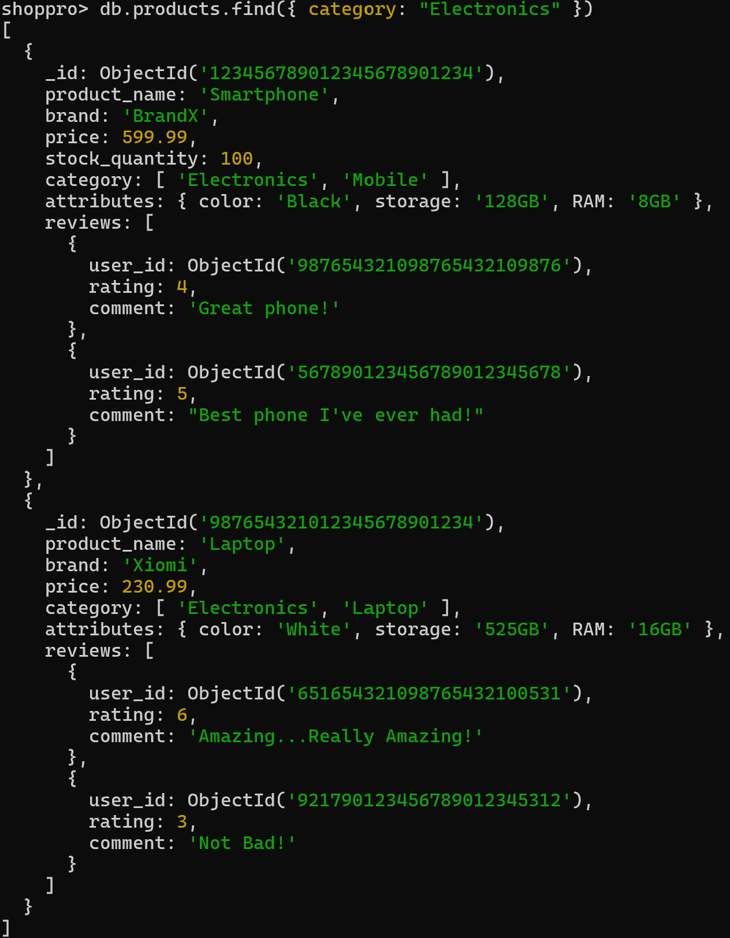

2. Find all products with a price less than $500

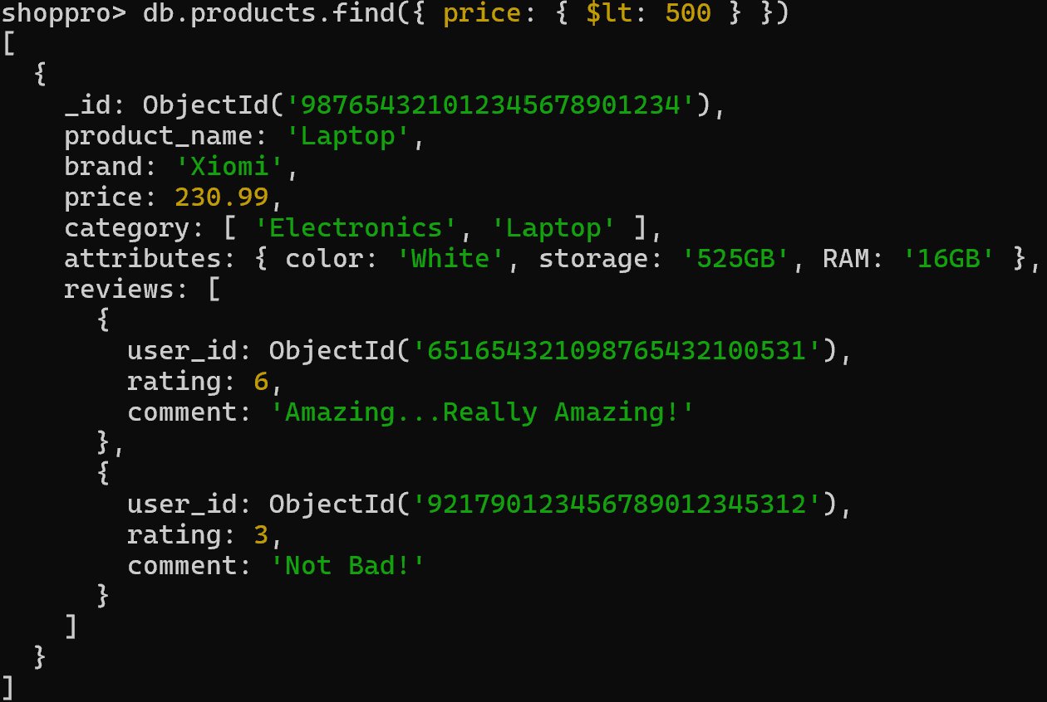

3. Retrieve all products with a rating greater than 4

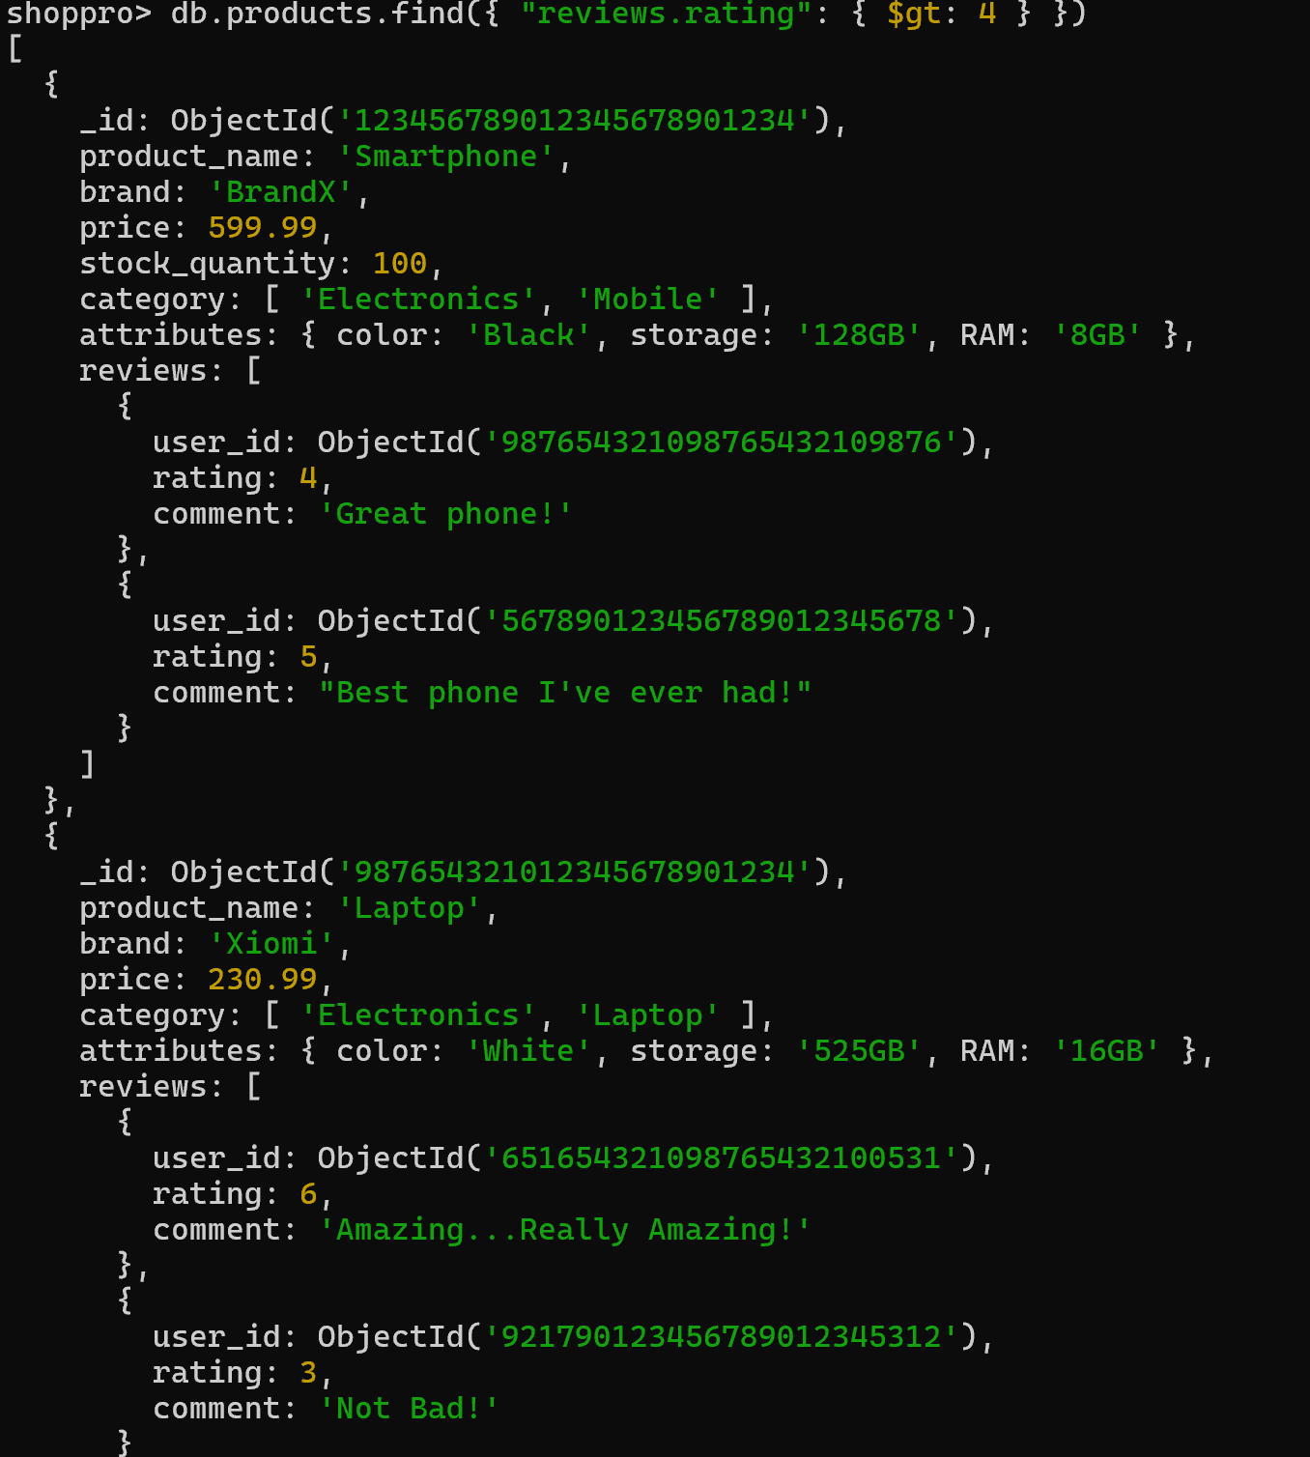

4. Find all products with a specific color (e.g., Black)

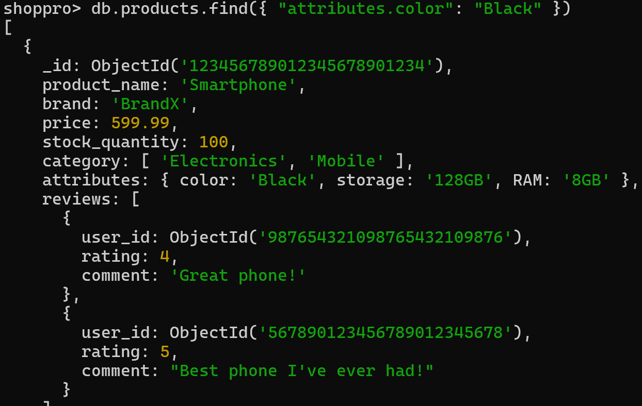

5. Retrieve all products sorted by price in descending order

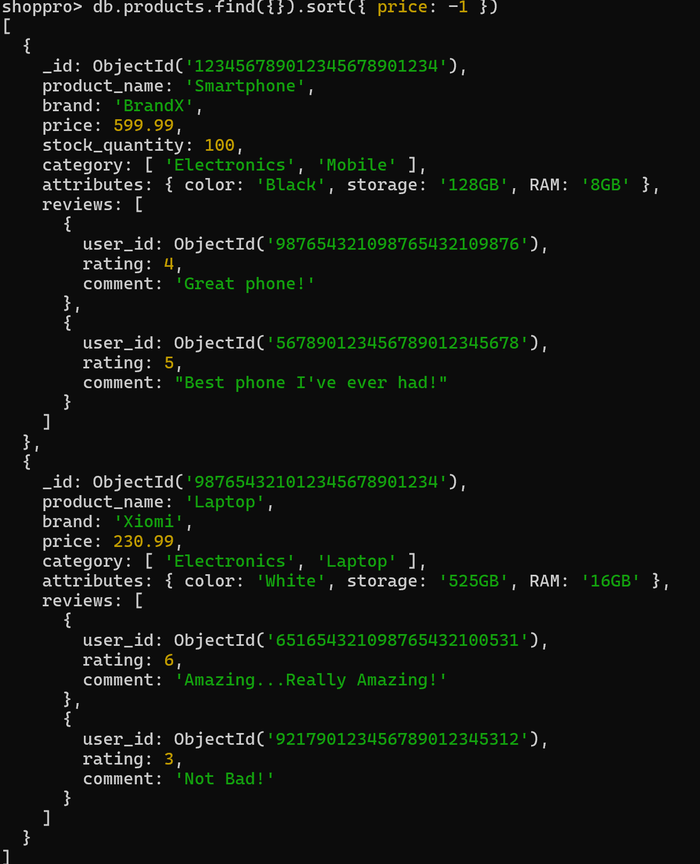

6. Calculate the average rating of all products

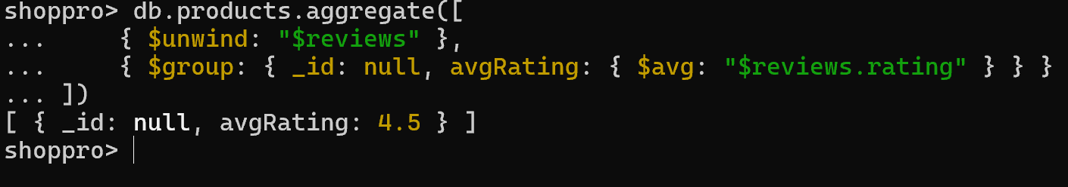

7. Find all products where the stock quantity is less than 10

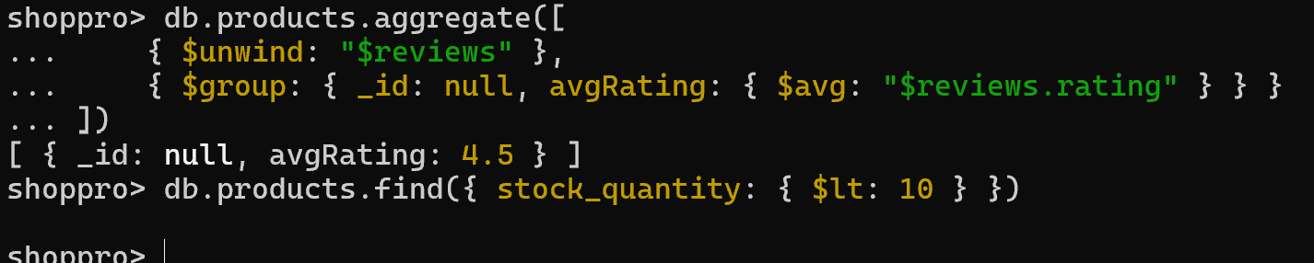

8. Retrieve all products with a specific brand (e.g., BrandX)

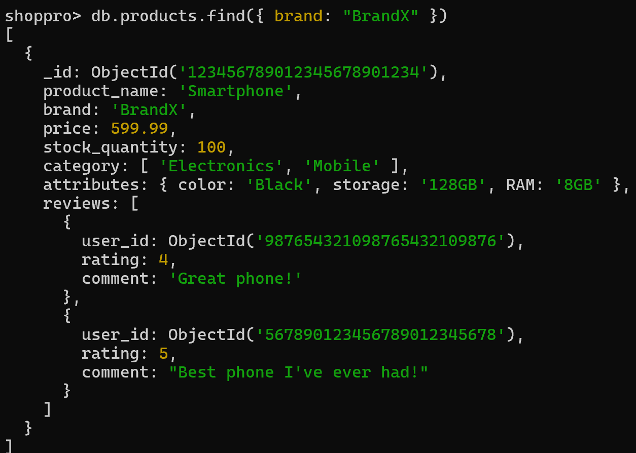

9. Find all products where the storage is 128GB and RAM is 8GB

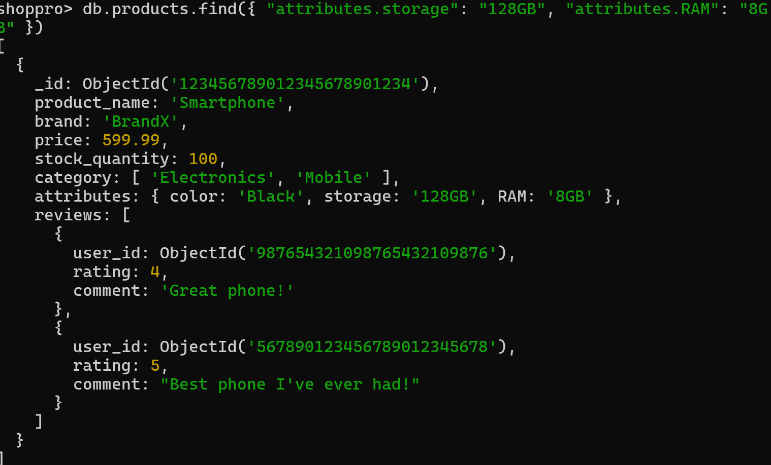

10. Retrieve all products with a specific user's review (e.g., user_id: ObjectId("987654321098765432109876"))

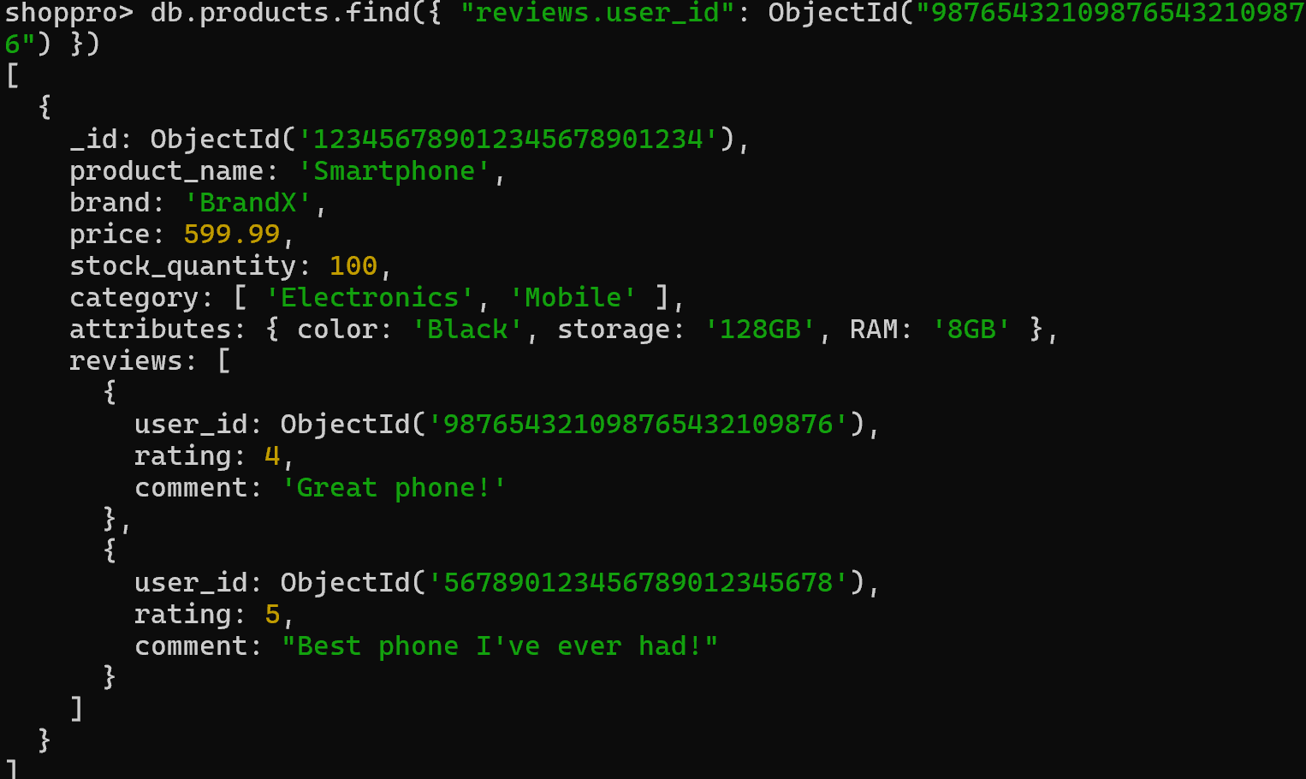

11. Calculate the total number of reviews for each product

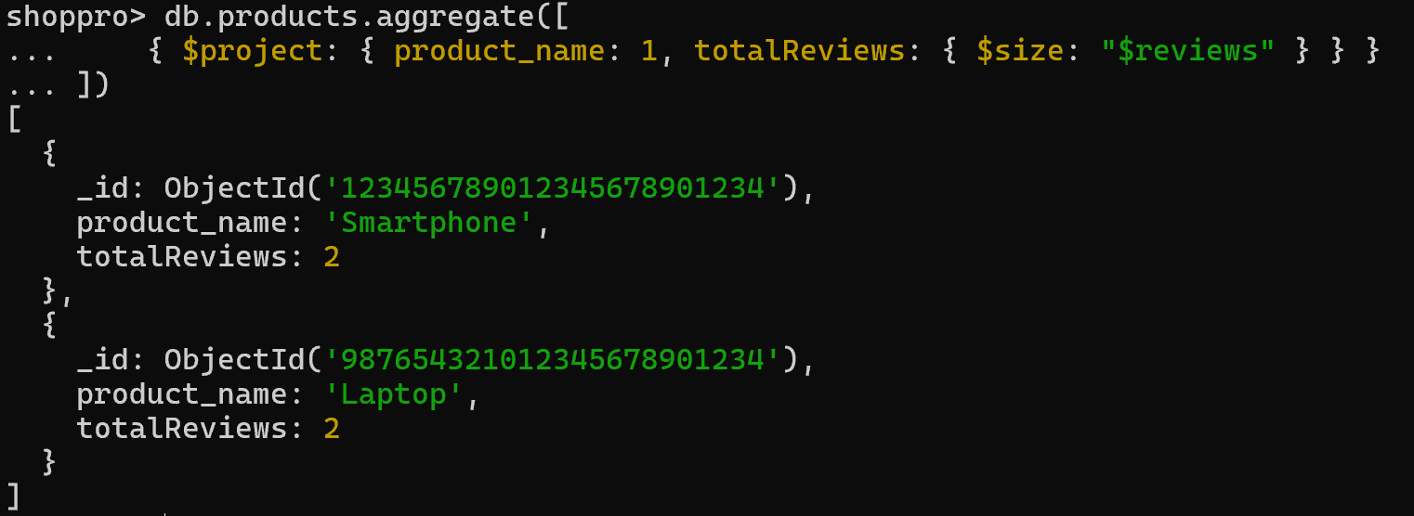

12. Find all products with a price between $400 and $600

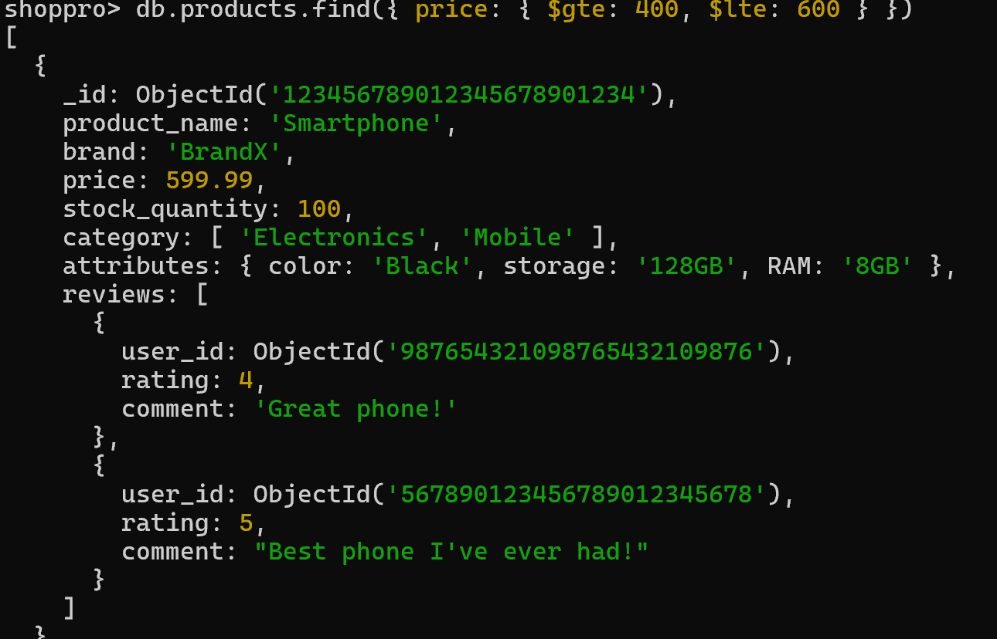

13. Find all products with a specific category (e.g., "Mobile") and a stock quantity greater than 50

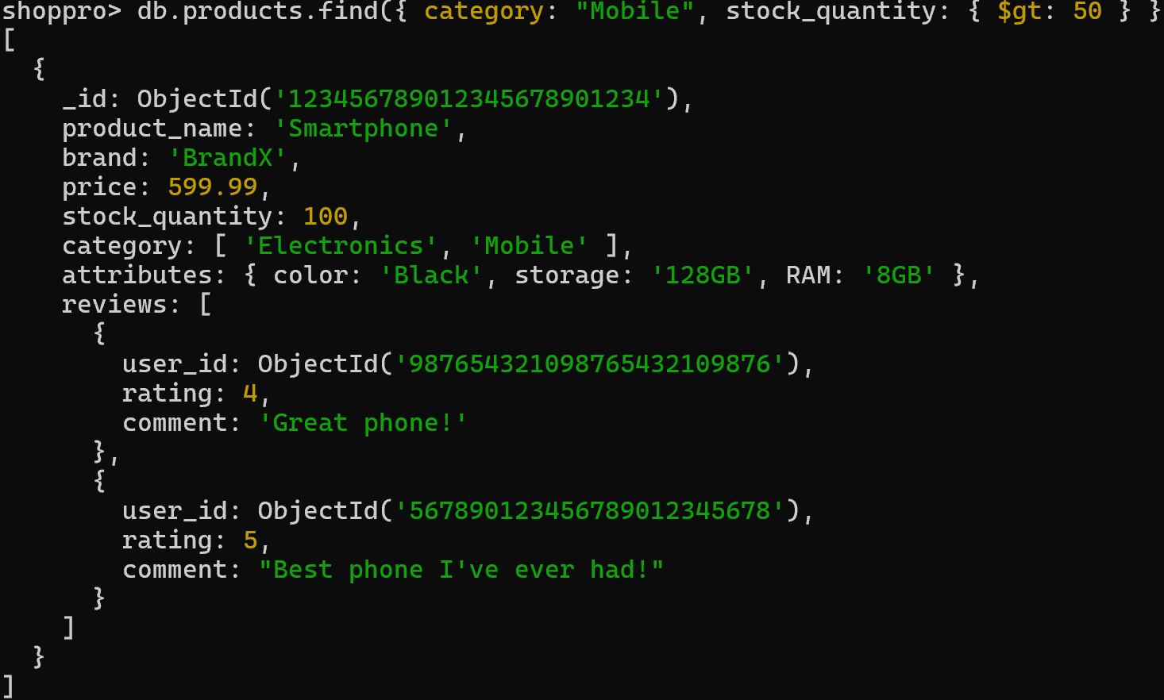

14. Find the highest rated product

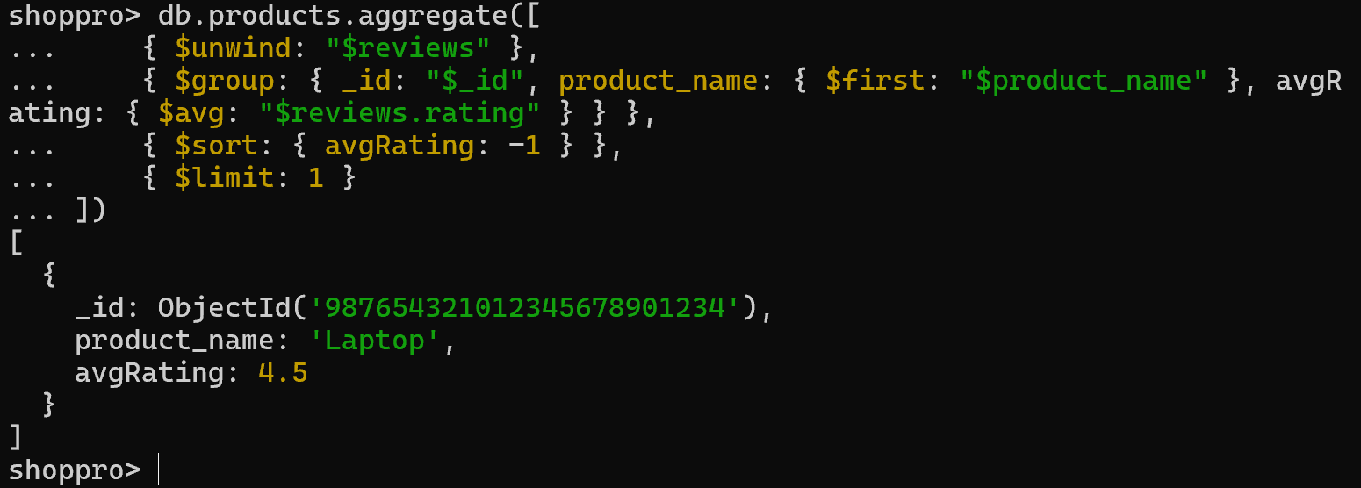

15. Retrieve all products sorted by brand in ascending order and then by price in descending order

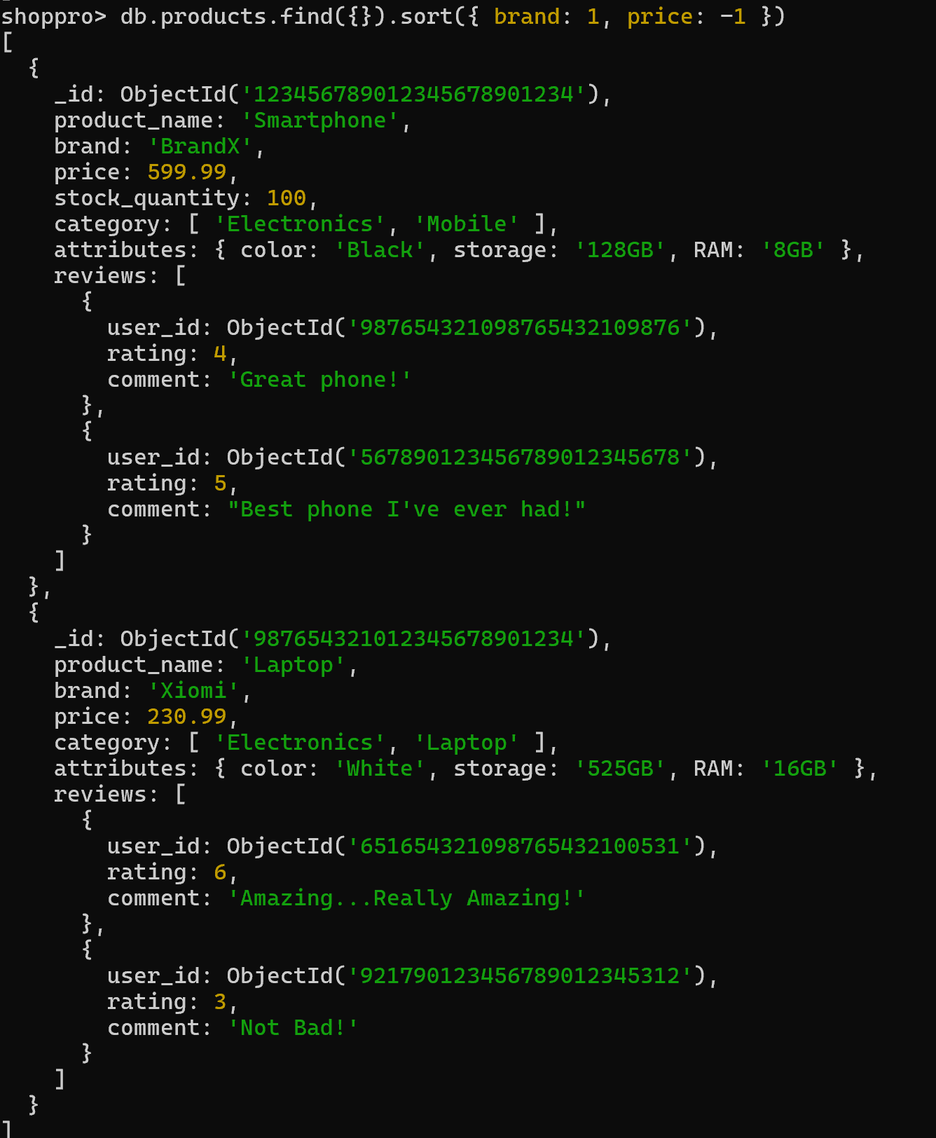

16. Find all products with a specific comment in their reviews (e.g., "Great phone!")

